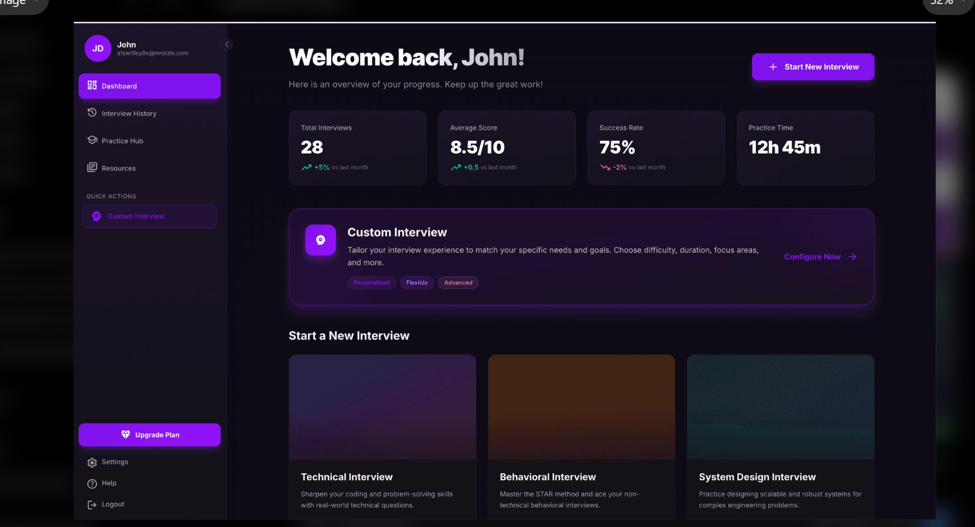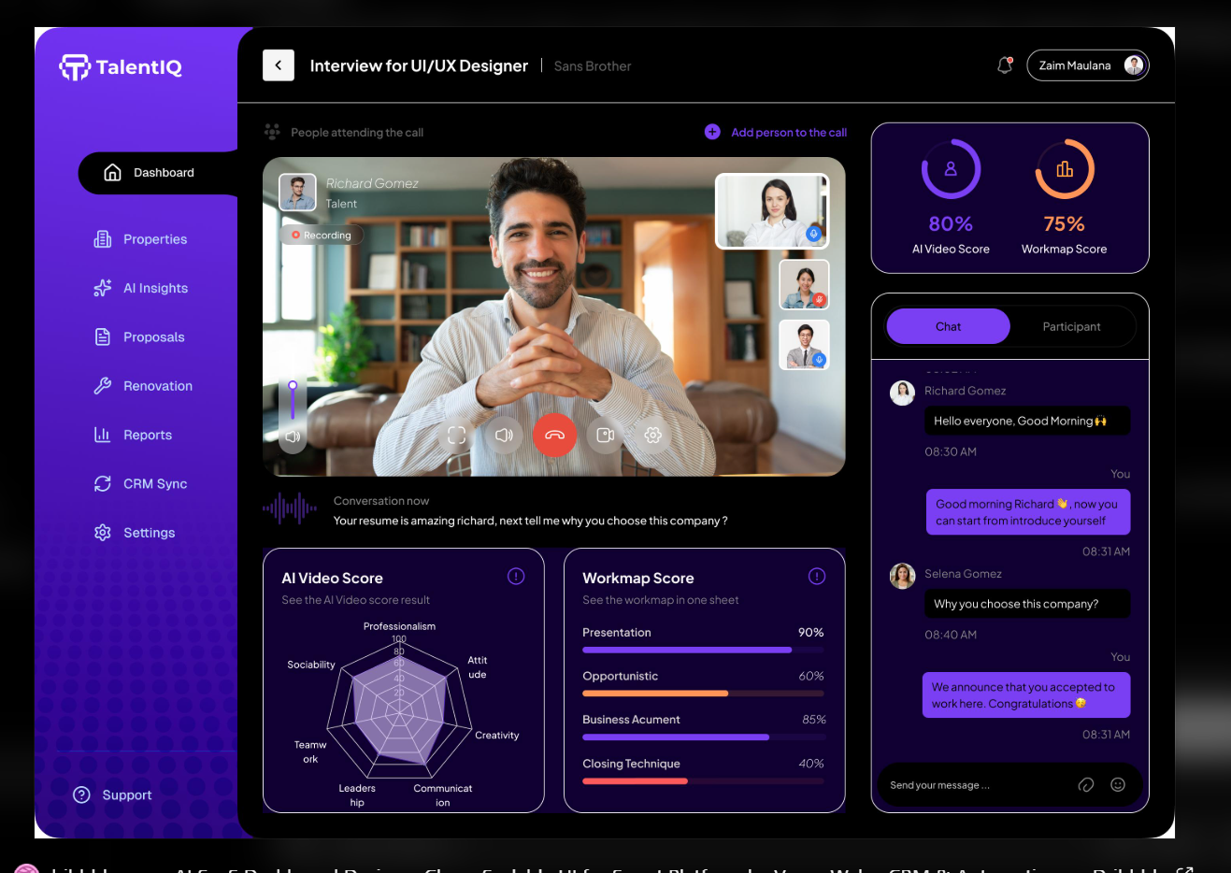

1. First, understand what we are building
There will be four major users/workflows:
- Student: Creates a profile, uploads a resume and selects a target role.
- AI Interviewer: Conducts a personalized technical interview.
- Evaluation Engine: Evaluates responses and identifies weak areas.
- Analytics Dashboard: Tracks performance and improvement over time.
2. Features we will develop
I suggest dividing development into four phases.
Phase 1 – Core platform
Must build first
- Registration and login using JWT.
- User profile and skill selection.
- Resume upload and parsing.
- Select target company and job role.
- Interview configuration.
- Interview history.
Phase 2 – AI Interview Engine
- Generate questions based on skills and resume.
- Dynamic follow-up questions.
- AI interviewer conversation.
- Answer evaluation.
- Technical feedback and scoring.
Phase 3 – Advanced functionality
- Voice-based interviews.
- Speech-to-text and text-to-speech.
- Coding interview environment.
- Real-time interview using WebSockets.
- Background processing using Redis and BullMQ.
Phase 4 – Production engineering
- Performance optimization.
- Security and rate limiting.
- Unit and integration testing.
- Docker and CI/CD.
- Cloud deployment.
- Monitoring and logging.
Important: We will not develop everything simultaneously. Each phase will be completed and tested before moving to the next.
3. Technology stack – final selection
I recommend the following architecture. It balances development speed with concepts that are valuable in backend interviews.
Layer | Technology | Purpose
Frontend | React + Vite | User interface
Styling | Tailwind CSS | Responsive UI
Backend | Node.js + Express | REST APIs
Database | PostgreSQL | Persistent data
ORM | Prisma | Database operations
Authentication | JWT + bcrypt | Secure login
Cache | Redis | Caching and session-related data
Job Queue | BullMQ | Background processing
Real-time | Socket.IO | Live interview communication
AI Service | Python + FastAPI | AI processing
AI | LLM API | Questions and evaluations
Deployment | Docker | Containerization
CI/CD | GitHub Actions | Automated testing and deployment
Architecture decision: Start with a modular monolith, not microservices. Keep the AI service separate because it uses Python, but don't unnecessarily split every backend module into its own service.
4. System architecture
Here is the proposed high-level architecture.
React Frontend
Dashboard · Resume · Interview · Analytics
Express Backend
Authentication · Users · Interviews · Reports · APIs
PostgreSQL
Users, questions, sessions, reports
Redis
Cache and job queues
Python AI Service
Question generation and evaluation
BullMQ Workers
Resume parsing and report generation
Example workflow:
- Student starts an interview.
- React sends a request to Express.
- Express creates an interview session in PostgreSQL.
- The AI service generates the first question.
- Student submits an answer.
- The AI evaluates the answer and generates a follow-up question.
- At the end, the system generates an interview report.
- The dashboard displays the performance.
5. Database design
Before writing APIs, design the database properly.
These are the main entities I recommend:
Table | Important fields
users | id, name, email, password_hash
profiles | user_id, education, experience, target_role
resumes | id, user_id, file_url, extracted_text
skills | id, skill_name, category
user_skills | user_id, skill_id, proficiency
interviews | id, user_id, company, role, difficulty, status
questions | id, question_text, topic, difficulty
interview_answers | interview_id, question_id, answer, score
evaluations | interview_id, technical_score, communication_score, feedback
interview_reports | interview_id, strengths, weaknesses, recommendations
Use proper foreign keys, indexes, constraints and timestamps.
For example, a user can have multiple interviews, and each interview can have multiple questions and answers.
6. API design
We will develop REST APIs in a structured way.
Method | Endpoint | Purpose
POST | /api/auth/register | Register
POST | /api/auth/login | Login
GET | /api/users/profile | Get profile
PUT | /api/users/profile | Update profile
POST | /api/resumes/upload | Upload resume
POST | /api/interviews | Create interview
GET | /api/interviews | Interview history
GET | /api/interviews/:id | Interview details
POST | /api/interviews/:id/start | Start interview
POST | /api/interviews/:id/answer | Submit answer
GET | /api/interviews/:id/report | Get evaluation
GET | /api/analytics/dashboard | Performance analytics
Keep authentication and authorization middleware separate. Every interview and report endpoint must verify that the requesting user owns the relevant resource.

7. Project folder structure
Use a clean structure from the beginning.

InterviewIQ/
│
├── frontend/
│ └── src/
│ ├── components/
│ ├── pages/
│ ├── layouts/
│ ├── hooks/
│ ├── services/
│ ├── context/
│ └── App.jsx
│
├── backend/
│ └── src/
│ ├── config/
│ ├── controllers/
│ ├── middleware/
│ ├── routes/
│ ├── services/
│ ├── repositories/
│ ├── validators/
│ ├── queues/
│ └── app.js
│
├── ai-service/
│ ├── app/
│ │ ├── routes/
│ │ ├── services/
│ │ ├── prompts/
│ │ └── schemas/
│ └── main.py
│
├── docker-compose.yml
├── .gitignore
└── README.md

InterviewIQ (TalentIQ) - Full-Stack Architecture & Execution Plan
1. System Overview
InterviewIQ is an end-to-end AI-powered interview preparation and live simulation platform designed for students and job seekers. The system provides real-time adaptive technical, behavioral, and system design mock interviews with instant dynamic feedback, radar scoring, and detailed performance analytics.

2. Workflows & Core Modules
1. Student Onboarding & Profile
- User registration and authentication with JWT and bcrypt.
- Profile management: target role, target company, education, experience level.
- Skills selection with category grouping and proficiency ratings.
- Resume upload (PDF/DOCX) with automatic text extraction, skill parsing, and summary extraction.
2. Interview Configuration & Catalog
- Dedicated interview tracks:
  - Technical Interview: Algorithms, data structures, full-stack, backend concepts.
  - Behavioral Interview: STAR method evaluation, situational dilemmas, communication.
  - System Design Interview: Architecture scalability, trade-offs, system robustness.
- Custom interview config: Company selection (Google, Meta, Amazon, Microsoft, Startups), role specialization, difficulty level (Junior, Mid, Senior, Lead), question count, and time limits.
3. Live AI Interview Simulation (TalentIQ Video HUD)
- Video Call Experience:
  - AI interviewer avatar with audio wave animation and live speaking status.
  - User video camera toggle and audio microphone input.
  - Subtitle bar: "Conversation now: [live interviewer voice transcription]".
  - Text-to-speech for AI question delivery & speech-to-text for candidate spoken responses.
  - Built-in interactive code editor for technical questions with syntax highlighting and code execution test preview.
- Real-Time Evaluation HUD:
  - AI Video Score (Radial gauge + 6-axis Radar Chart):
    - Professionalism
    - Attitude
    - Creativity
    - Communication
    - Leadership
    - Teamwork
  - Workmap Score (Radial gauge + 4 breakdown bars):
    - Presentation
    - Opportunistic
    - Business Acumen
    - Closing Technique
  - Interactive transcript & live chat panel.
4. Evaluation Engine & Reporting
- Question-by-question scoring and immediate AI feedback.
- Dynamic follow-up question generation tailored to the candidate's actual answer.
- Final comprehensive report:
  - Overall performance score, Technical score, Communication score.
  - Key strengths, weaknesses, and concrete actionable recommendations.
  - Detailed answer-by-answer breakdown with ideal answers.
5. Analytics Dashboard
- Metric cards: Completed Interviews, Average Score, Accuracy Rate, Practice Time.
- Performance charts, interview history list with status badges, and quick re-take links.

3. Technology Stack & Directory Structure
Layer | Technology | Role
Frontend | React 19, Vite, Tailwind CSS, Lucide Icons, Recharts | Sleek dark-mode dashboard and live video call room
Backend | Node.js, Express, Socket.IO, JWT, bcryptjs, Multer | RESTful API, authentication, real-time sessions, resume storage
Data Layer | SQLite (local dev) / PostgreSQL (production), Prisma | Structured relational data model
AI Service | Python, FastAPI, Pydantic, LLM Integration | Prompt engineering for interview questions, follow-ups, and grading
DevOps | Docker Compose, GitHub Actions, Dockerfiles | Containerized local and cloud deployment
Exact Directory Layout
InterviewIQ/
├── frontend/
│ ├── src/
│ │ ├── components/ # VideoGrid, RadarScore, WorkmapScores, CodeEditor, AudioVisualizer
│ │ ├── pages/ # Dashboard, InterviewRoom, InterviewReport, Profile, NewInterview
│ │ ├── layouts/ # AppLayout, Sidebar, Navbar
│ │ ├── hooks/ # useSpeechRecognition, useSpeechSynthesis, useSocket
│ │ ├── services/ # api.js, authService.js, interviewService.js
│ │ ├── context/ # AuthContext.jsx, InterviewContext.jsx
│ │ ├── App.jsx
│ │ ├── main.jsx
│ │ └── index.css
│ ├── package.json
│ └── vite.config.js
│
├── backend/
│ ├── src/
│ │ ├── config/ # db.ts, env.ts
│ │ ├── controllers/ # authController.ts, userController.ts, resumeController.ts, interviewController.ts, analyticsController.ts
│ │ ├── middleware/ # authMiddleware.ts, uploadMiddleware.ts, errorMiddleware.ts
│ │ ├── routes/ # authRoutes.ts, userRoutes.ts, resumeRoutes.ts, interviewRoutes.ts, analyticsRoutes.ts
│ │ ├── services/ # authService.ts, resumeService.ts, interviewService.ts, aiBridgeService.ts
│ │ ├── repositories/ # userRepository.ts, interviewRepository.ts, resumeRepository.ts
│ │ ├── validators/ # authValidator.ts, interviewValidator.ts
│ │ ├── queues/ # jobQueue.ts
│ │ └── app.ts # Express app & Socket.IO server setup
│ ├── package.json
│ └── tsconfig.json
│
├── ai-service/
│ ├── app/
│ │ ├── routes/ # interview_routes.py, evaluation_routes.py
│ │ ├── services/ # llm_service.py, question_generator.py, evaluator.py
│ │ ├── prompts/ # interview_prompts.py
│ │ └── schemas/ # schemas.py
│ ├── main.py
│ └── requirements.txt
│
├── docker-compose.yml
├── .gitignore
└── README.md

4. Execution Phases
- Phase 0: Environment & Dependency Setup
  - Configure frontend dependencies (React, Tailwind, Lucide, Axios, Socket.IO Client).
  - Configure backend dependencies (Express, CORS, JWT, bcryptjs, Multer, Socket.IO, Zod, TypeScript, TSX, pdf-parse).
  - Configure Python AI service dependencies (FastAPI, Uvicorn, Pydantic).
- Phase 1: Backend Architecture & Core APIs
  - Implemented Database schema with Prisma (backend/prisma/schema.prisma) and relational storage manager (backend/src/config/db.ts).
  - Implemented JWT authentication & authorization middleware (/api/auth/*).
  - Implemented user profile and skills selection endpoints (/api/users/profile).
  - Implemented resume upload and text extraction with parsing (/api/resumes/upload).
  - Implemented interview session management (/api/interviews, /start, /answer, /report).
  - Implemented analytics summary calculation endpoint (/api/analytics/dashboard).
- Phase 2: AI Service (Python FastAPI)
  - Implemented question generation routes tailored to role, target company, difficulty, and resume.
  - Implemented real-time dynamic follow-up generator based on candidate's answers.
  - Implemented evaluation engine for technical accuracy, communication, 6-axis video radar scores, and 4-axis workmap scores.
  - Implemented final report generator with strengths, weaknesses, and actionable recommendations.
  - Implemented Backend aiBridgeService with internal fallback engine for zero-dependency resilience.
- Phase 3: Frontend TalentIQ UI Implementation
  - Implemented dark-themed App Layout with collapsible sidebar matching design mockups.
  - Implemented Overview Dashboard with 4 metric cards, Custom Interview configuration banner, and 3 interview tracks.
  - Implemented Live Interview Simulation Room:
    - AI interviewer video feed & audio wave visualizer.
    - Candidate webcam preview (PiP).
    - Subtitle bar: "Conversation now: ...".
    - Interactive 6-axis Radar Chart (RadarScore.jsx) and Workmap progress meters (WorkmapBars.jsx).
    - Web Speech API (STT & TTS) + live sandboxed code editor + chat & transcript drawer.
  - Implemented Interview Report View & Analytics charts.
  - Implemented Profile & Resume Upload View with instant parsed skills preview.
- Phase 4: Production Engineering & Verification
  - Created docker-compose.yml for single-command orchestration (Postgres, Redis, AI, Backend, Frontend).
  - Created Dockerfiles for backend, ai-service, and frontend (Nginx reverse proxy).
  - Created complete documentation in README.md.
  - Executed end-to-end integration test suite (backend/test-api.js), passing 8/8 test phas

